ARTS STATIONARY

E-project

User Guide

|  |  |
| --- | --- |
| ENROLLMENT ID | NAME |
| Student1412244 | MUHAMMAD KASHAN ALI |
| Student1412217 | AHMED SHAHID |
| Student1452386 | Maham Noor |
| Student1397491 | Muhammad Slaman |
| Student1416160 | MALIHA SHAHID |

**Supervisor:** Sir Shahryar

**Co-Ordinator:** Miss Wajiha Ashfaq



**Problem Statement**

Problem statement is attached separately in a file “**Online Shopping Cart**”

**Standards plan:**

Every code block must have comments.

The logic of the program needs to be explained. Proper documentation should be maintained.

Complete Project Report along with synopsis, code and documentation should be prepared.

**Documentation:**

No project is complete without documentation. In fact, it is one of the most important activities during the development of a project. The documentation of an ideal project will be in the form of a project report comprising of the following documents:

* Certificate of Completion.
* Table of Contents.
* Problem Definition.
* Customer Requirement Specification.
* Project Plan.
* E-R Diagrams.
* Algorithms.
* GUI Standards Document.
* Interface Design Document.
* Task Sheet.
* Project Review and Monitoring Report.
* Unit Testing Check List.
* Final Check List.

**Hardware/ Software Requirements**

**Hardware**

* A minimum computer system that will help you access all the tools in the courses is a Pentium 166 or better
* 128 Megabytes of RAM or better

**Operating System**

* LINUX / Windows 2000 Server (or higher if possible)

**Software**

* PHP
* MySQL
* PERL
* Apache

**ADMIN PANEL:**

**ADMIN LOGIN:**

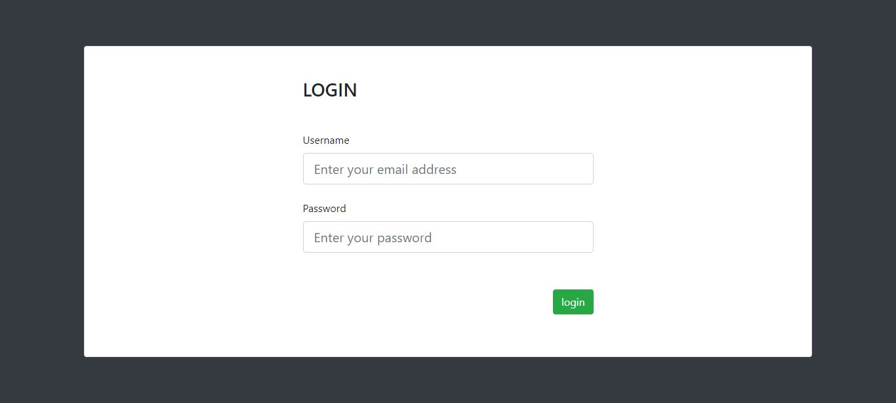

**HOME SCREEN:**

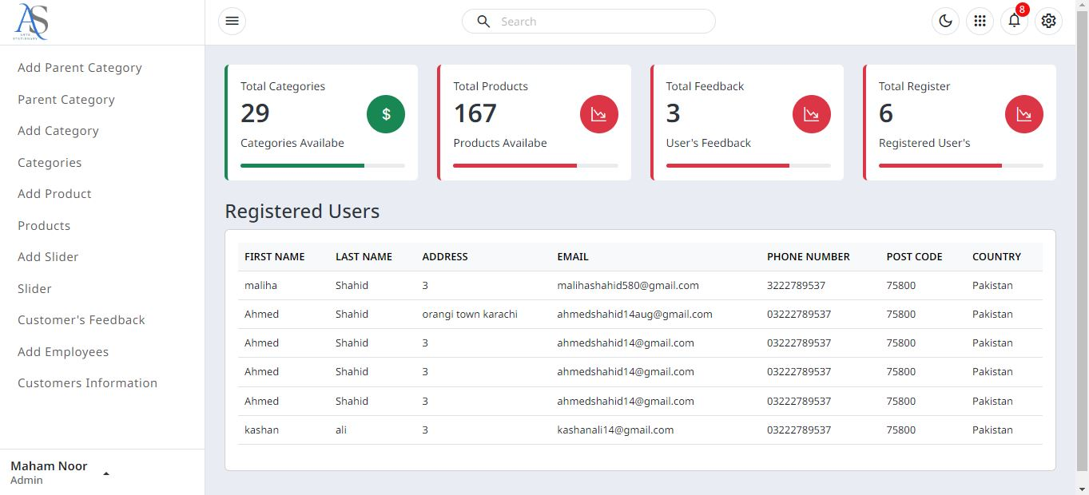

**ADD DATA:**

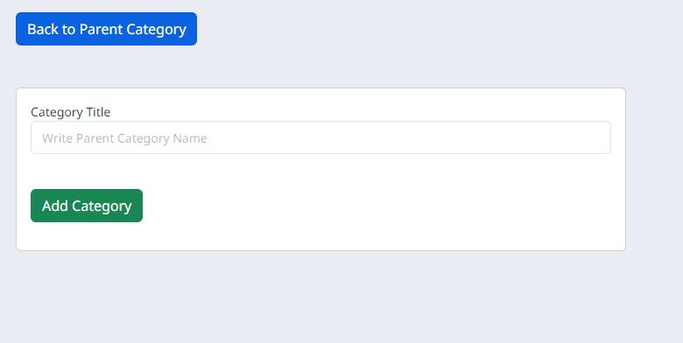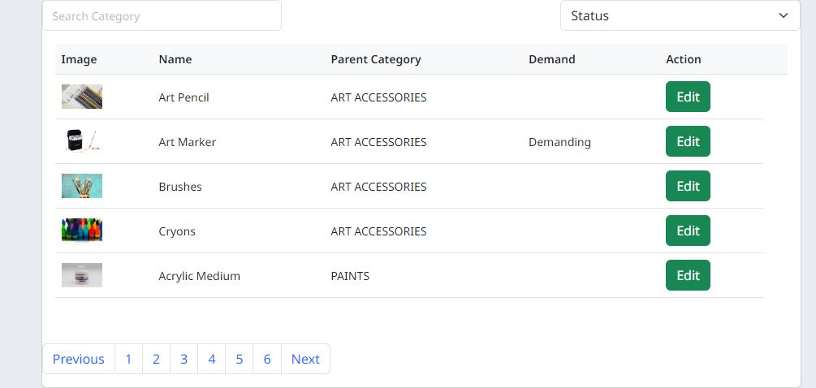

**ADMIN ADD EMPLOYEES OR USER:**

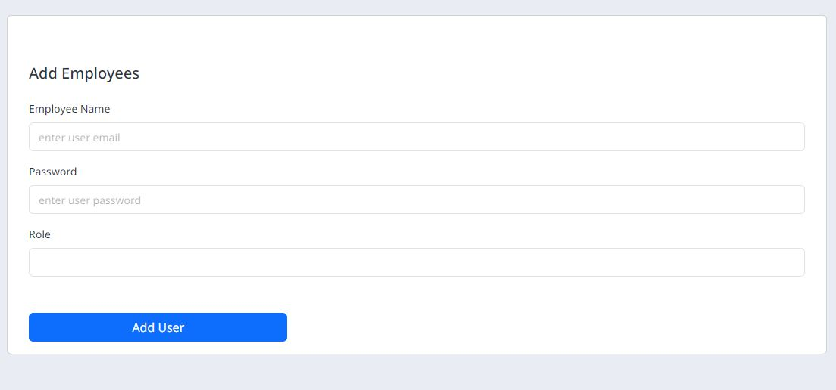

**CUSTOMER’S FEEDBACK:**

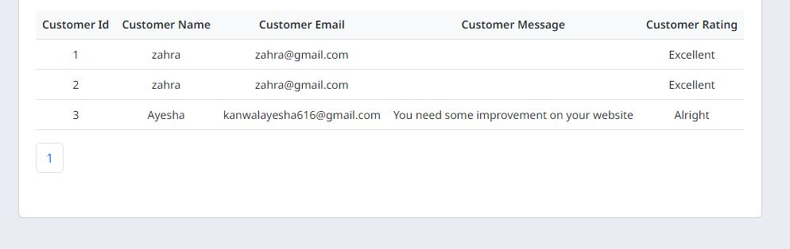

**USER PANEL:**

**Parking**

**NAVBAR:**



**FOOTER:**



**PRODUCTS PAGE:**

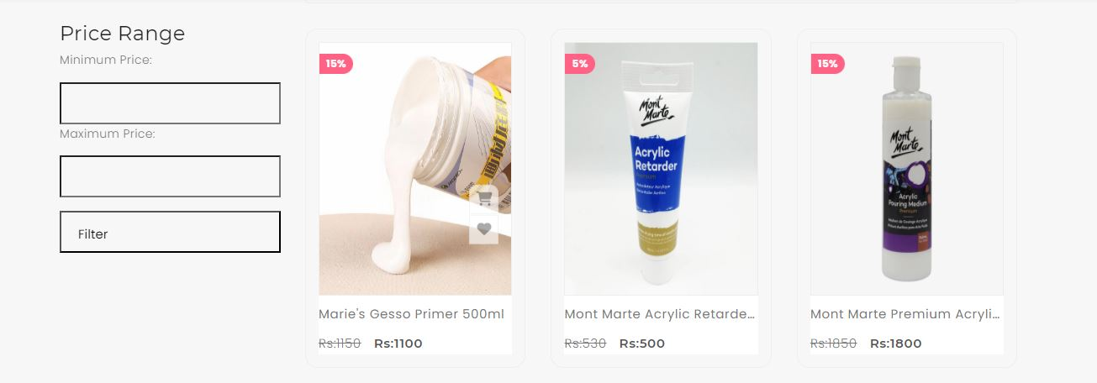

**DESCRIPTION PAGE:**

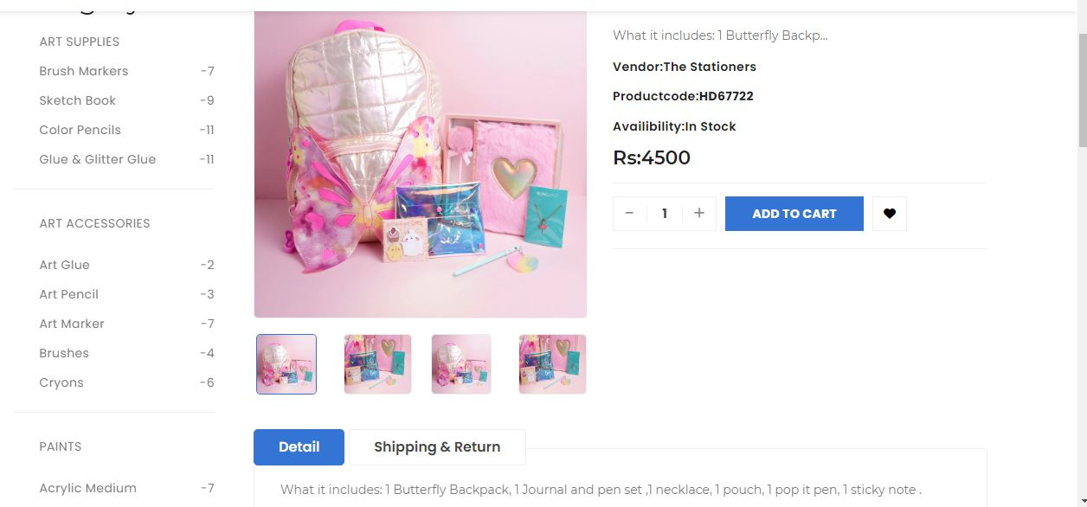

**ADD TO CART:**

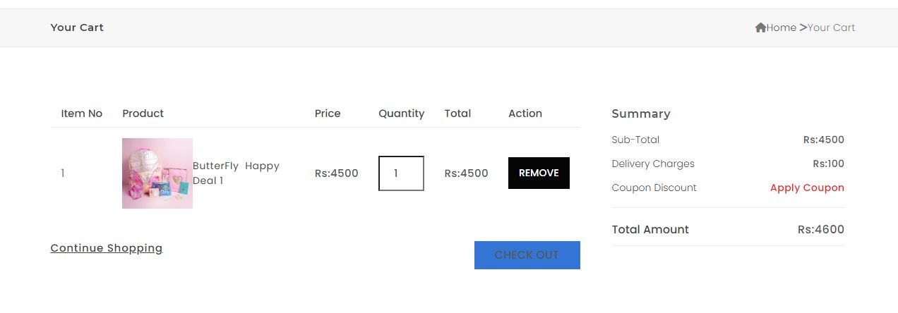

**WISHLIST:**

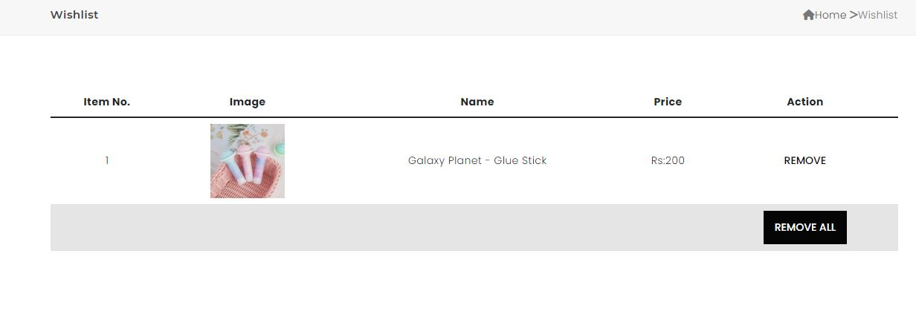

**FILTER:**

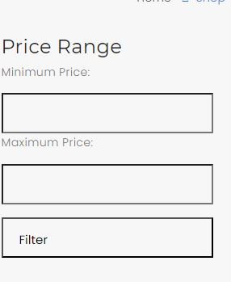

**REGISTER FORM:**

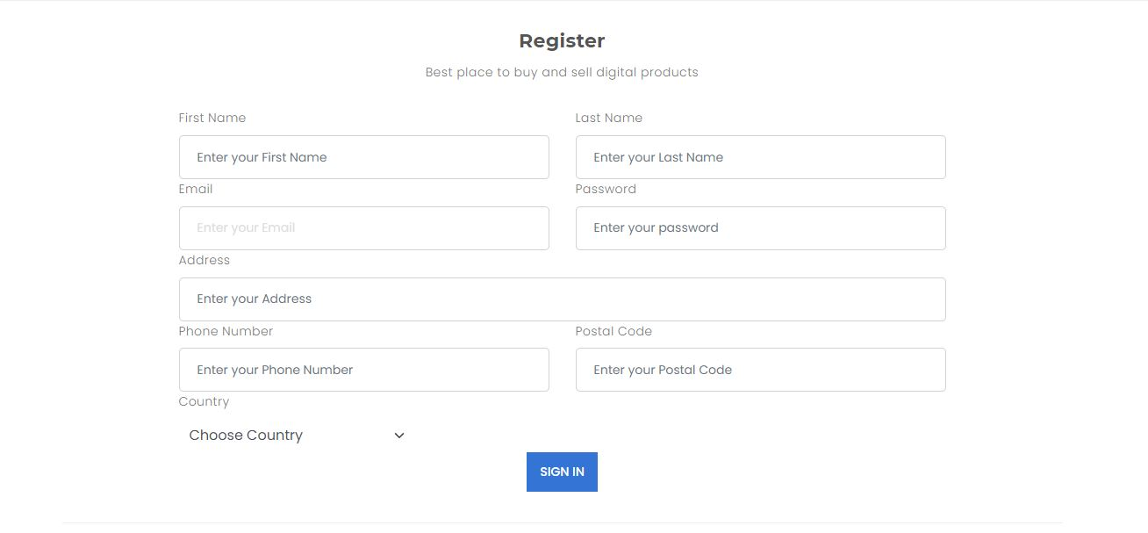

**FEEDBACK FORM :**

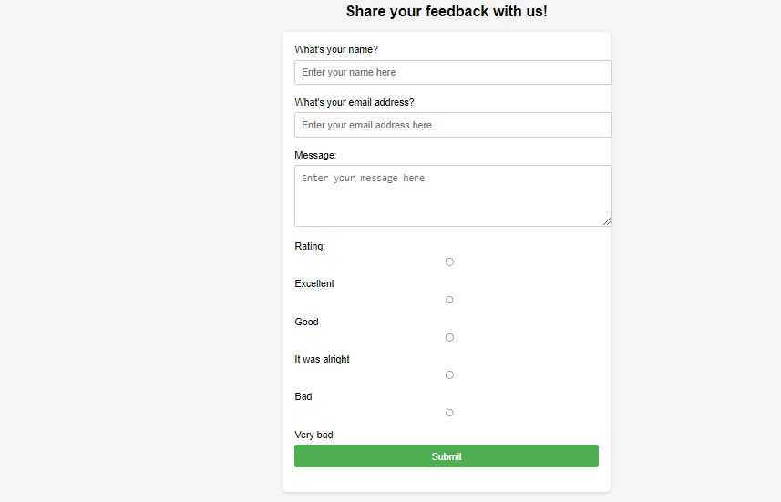

**DATABASE:**

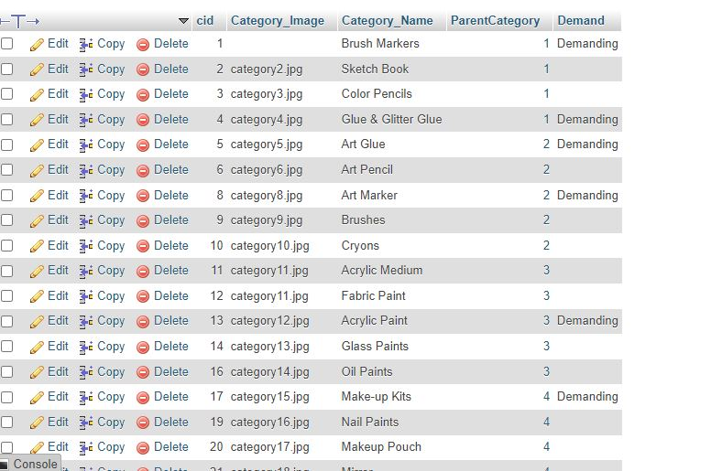

**TASK SHEET :**

|  |  |  |  |  |  |
| --- | --- | --- | --- | --- | --- |
| **S.No** | **Task** | **Project Title** | **Actual Days** | **Team Mate Name** | **Status** |
| 1 | Admin Panel  Database Creation  Website Maintenance  AJAX- Complete  Add to cart  Wishlist | Arts | 10 | Maham Noor | Complete |
| 2 | Feedback  About us  Faqs  Documentation | Arts | 5 | Kashan Ali | Complete |
| 3 | Registration  Index page | Arts | 7 | Ahmed Shahid | Complete |
| 4 | Wishlist  Crud operation  Terms and conditions  Privacy & Policy | Arts | 3 | Maliha | Complete |
| 5 | Documentation | Arts | 3 | Salman Khan | Complete |